**COMSATS University Islamabad, Abbottabad Campus**

**Department of Computer Science**

**Project Proposal**

**School Management System**

**CSC392 Object Oriented Software Engineering**

Submitted on: <23-APR-2022>

Group Members:

Afaq (FA20-BSE-057)

Ali Said(FA20-BSE-4B-165)

Muhammad Nawaz Khan (FA20-BSE-073)

Abdullah Javed (FA20-BSE-052)

Ehsanullah (FA20-BSE-068-4B)

Faizan Zaheer (FA20-BSE-045)

Irfan Khan (FA20-BSE-070)

Table of Contents

CHAPTER 1 PROJECT PROPOSAL 3

Introduction 3

Vision and Business Case 3

Use-Case Model 3

Supplementary Specification 3

Glossary 3

Risk List & Risk Management Plan 3

CHAPTER 2 USE CASES 4

Use Case Diagram 4

Brief Level Use Cases 4

Student Name 1 (Registration Number 1) 4

Student Name 1 (Registration Number 1) 5

# CHAPTER 1 PROJECT PROPOSAL

## Introduction

School Management system, required for effective software development, to manage the overall data of a school

## Vision and Business Case

In the offline system, it is an overhead to keep the records related to faculty, student, parents, and other school staff on the papers. Everything related to their progress in the system is marked manually. For example A report of a student’s attendance is generated monthly is shown to his/her parents. Now, a regular student, going to school every day, is marked absent for a day by mistake.

It is a burden to take out the register and view the records. As you can see, it is a very time-consuming process and it costs much. So, I thought why I should not help these young guns of the nations to help them to have a bright future and to make an online centralized platform that can be accessed from anywhere in the world.

My other aim is to minimize the paperwork as minimum as I can so that there is no need to cut more and more trees. Indirectly, I will be helping Mother Nature.

## Use-Case Model

The functional requirements of school management system are:

1. Multi-User Account System
2. Student Fee Management
3. Parent Monitoring Feature
4. Homework Document
5. Class Routine Schedule
6. Profile System
7. Exam Marks Management
8. Chart & Graph Analysis of Exams
9. Daily Attendance
10. Internal Messaging

## Supplementary Specification

1. Events management

## Glossary

## Having a dynamic system with a bird view of data and reports can give next level of power and quickness in decision-making for principal or management person. School management System provides extra ordinary Management Dashboard and data reporting functions along with dynamic access rights mechanism which becomes a blessing for management personnel.

## Risk List & Risk Management Plan

***Describes the risks (business, technical, resource, schedule) and ideas for their mitigation or response.***

**1. Malware**

Digital hackers are watching your every move and trick you to download malware and take control of your computer remotely. They use malware to attack computer networks to perpetrate crimes.  Fraudsters use virus, malware, spyware, spams, and phishing to gain access to your sensitive personal information and commit financial crimes. Defend your data against malware through secure servers, whether physical or in cloud, and shield against vulnerabilities.

**2. Theft & Loss**

Unauthorized users without permissions who have access to sensitive data can cause harm to educational institutions as a result of theft. There is a risk of the sensitive academic data will be leaked by staff. It becomes easy to lose your storage media with backup data due to misplacement or theft. When you suffer data loss due to various incidents such as mechanical damage, power failure, software crash, disasters or loss of your laptops and mobile devices, it is another way of inadvertent data exposure. Keep all your data safe and secure using role-based access control to ensure confidentiality and privacy.

**3. Unsafe data**

If adequate safety precautions are not taken when files and documents are shared in website, smartphones and tablets via internet networks, the information contained on them might gain access to the devices and get exposed to risks. We can make use of cloud deployments to manage the education system better and better.

**4. Negligence**

When data is stored in computers or laptops, it has become so natural that people lose the information when files are accidentally deleted or even it could fall into the wrong hands. Ensure a proper backup strategy to keep your data on important devices and run them smoothly without hassles.

# CHAPTER 2 USE CASES

## Use Case Diagram

## Brief Level Use

## Brief level use case:

Muhammad Nawaz Khan(FA20-BSE-073)

#### Use case: View Attendance

View attendance use case will use take attendance of students and faculty the attendance of faculty will be through biometric, and the record will be saved in database and the attendance of student will be taken by teachers and the record will be submitted on system. The admin and teacher can modify and view the attendance of student. The guardian and student can only view attendance.

### Ali Said(FA20-BSE-165)

#### Use Case: About Exams

In about exams use case faculty or staff can take exams directly from about exams section and take assignments directly from sub section assignments in about exams. It would be so ease for students as well as teachers to take/give exam or assignment in soft form . Teachers have to feed the questions on the about exams section after that teacher can set the timings for assignments or quizzes and set a deadline for submission. Exams marks would be marked automatically by the system but if teacher wants to change or over write he/she has access to do that. Students have access to upload file for assignments.

### Afaq (FA20-BSE-057)

#### Use Case: Time Table

In school management system time table is necessary so it is strong entity. From time table students can see their time table and takes classes according to their time table slot. Faculty can also take classes according to their time table. Guardians able to see their children time table and keep eye on their class’s times. School administration will set time and classes to each and every class from first grade to matric level. Every class has unique time table and subjects.

### Abdullah Javed (FA20-BSE-052)

#### Use Case: Subjects Management

### In this use case students will be asked by the administrators to add class. After adding class there are certain subjects that are taught in that particular class added by student. Administrator is allowed to add or remove subjects from class, while students are bound to see only the subjects list. On the basis of subjects admin can assign instructor in each subjects. Faculty members can also list down the subjects they want to teach. Guardians are also eligible to see the subjects of student.

### **Ehsanullah (FA20-BSE-068)**

#### Use Case: About Result

About Result use case will generate the result for student based on their request for view the result for the subjects. The results of student will be taken by teachers and the record will be submitted on system. The admin and teacher can modify and view the result of student. The guardian and student can only view the result.

### **Faizan Zaheer (FA20-BSE-045)**

#### Use Case: Add Events

In Events Usecase Event Manager Will Add the Event,View events,delete events,monitor events status online,manage series and schedules of events ,monitor Venue and Parcipants records and show the list of parcipants and release the schedules of events and events detail.Event Manager make changes or modify the events and parcipants view the Events and schedule of events.

#### Use Case: Delete Events

In Events Usecase Event Manager Will delete events,monitor events status online, monitor Venue and Parcipants records and show the list of parcipants and release the schedules of events and events detail.Event Manager make changes or modify the events and parcipants view the Events and schedule of events.

#### Use Case: View Events

In Events Usecase Event Manager Will Add the Event,View events,delete events,monitor events status online,manage series and schedules of events ,monitor Venue and Parcipants records.

#### Use Case: Manage Events

In Events Usecase Event Manager Will manage series and schedules of events ,monitor Venue and Parcipants records and show the list of parcipants and release the schedules of events and events detail.Event Manager make changes or modify the events and parcipants view the Events and schedule of events.

### Irfan khan FA20-BSE-070

#### Use Case: register account

User opens the School management system and clicks on the register button. The system takes the user to the registration page. The user is required to enter information asked by the system. The user then enters his full name, email, address, phone number and password. The system then checks if the user is already registered or not. If he is not registered the system validates and registers him as a Student.

Fully dressed use case:

### Muhammad Nawaz Khan (FA20-BSE-073)

| Use Case UC1: View Attendance |
| --- |

**scope**: view attendance

**primary Actors**: faculty, admin.

**Stake holder and interest:**

Teacher: Teacher wants to take attendance easily without any error and don’t want to carry extra register to mark students’ attendance.

Faculty: it is easy for faculty to mark attendance using biometric and the attendance is updated directly

In the system and there is less chance of errors to forgot attendance.

Student: students want to get rid of traditional list to check their attendance and the system is very useful to for student to view their updated attendance.

Guardian: The system also alerts the guardian if the student is absent.

Admin: managing the teachers and student attendance and classes this system is very difficult for admin.

The system generates class wise attendance lists and inform that which faculty member is absent.

**Preconditions:** student, teacher and admin must be identified and authenticated.

**Success guarantee** (or Postconditions): The process of Taking attendance become easy. View real time attendance. Accurate attendance Report for admin.

**Main success scenario or Basic flow:**

* Faculty marks their attendance through biometric.
* Teacher marks attendance of students using the system and records is saved in the database.
* The system generates attendance report for admin.
* System alert guardian if the student is absent.
* Students and guardians can view the real time attendance.

**Extension or alternative flows:**

At any time, the internet can be gone:

* During the marking or updating attendance any time the internet connection may be gone.
* The system will be interrupted, and the teacher will not be able to use the system.
* After the fixing the internet, the user will login and continue back to his work.

At any time, system fails:

* The system can fail any time. The system it will save the work.
* User will restart the system and request for recovery the system will start from the prior state.

If system does not recover:

* The user will suspend the operation and the system will show an error message.
* The user starts a new operation and continue to his work.

**Special requirements:**

* The user should have the computer to use the system.
* The internet must be connected.
* The user should be authorized and authenticated.

**Technology and Data Variations List**:

The must have computer connected to internet.

### Ali Said (FA20-BSE-165)

| Use Case UC1: About Exams |
| --- |
| **Scope**: School Management System  **Level**: user goal  **Primary** **Actor**: Student, Guardian, Faculty, Admin.  **Stakeholders and Interests**:  - Admin: Admin is the one who controls the whole school management system, its staff, and every other person or thing that is associated with the school. In other term, the admin is the most powerful entity of the system.  -Teacher: The teacher is one of the important entities for a school. The teachers are there to teach the students. The following are the features that will be available to the teachers.  -Student: The student is also one of the main parts of the system. The students can log in to the student account anytime they want.  -Parents/Guardians: It is important for the parents to be familiar with the status of their child how they are performing in the academy. To make this hassle-free, there is also an option available for the parents.  **Preconditions**: Students are identified and authenticated. |

**Success Guarantee** (or Postconditions): Teachers will feed questions and answers and then they will take quiz. Students have to give timeboxed quiz. After that system will automatically mark the quiz on the basis of feed questions.

**Main Success Scenario (or Basic Flow):**

1. Teacher will store the questions on the about exams section before taking quiz/assignment.
2. Teacher will set the deadline/duration of assignment/quiz.
3. Students will be notified about quiz or assignments in notification section.
4. Students will start the quiz or students will download the assignment file.
5. After answering few questions their quiz will end up or they can upload the assignment before deadline.
6. After deadline there will be no option available for quiz/assignment.
7. System will automatically mark the quizzes but in case of assignments teacher have to practically do it.
8. After teacher`s marking result will be sent to the result section and will be publicly available to students.

**Extensions (or Alternative Flows):**

At any time, admin requests can override operation:

1. The teacher set the exam.
2. Admin wants any other operation at that time frame.
3. The admin operation will override the teacher operation.
4. Teacher operation will be set to next timeframe available.

**Special Requirements:**

- Touch screen UI on a large flat panel monitor. Text must be visible from 1 meter.

- Page response within 3 seconds 90% of the time.

- Language internationalization on the text displayed.

**Technology and Data Variations List**:

1. Teachers can set up fingerprint or face unlock.

### Afaq (FA20-BSE-057)

| Use Case UC1: View Timetable |
| --- |
| **Scope**: Time Table  **Primary** **Actor**: Student, Guardians, Faculty, Administration  **Stakeholders and Interests**:  - Student: student can visit his/her time table on daily basis and attend their classes according to their time table  - Teachers: Teachers will also take classes according to their time table.  -Guardians: Guardians can also watch their children time table  - Administration: School administration can modify time table on daily basic according to class rooms available. Each class from grade first to matric has unique time table and subjects.  **Preconditions**: Students, faculty, guardians and administration must be identified and authenticated. |

**Success Guarantee** (or Postconditions): Online time table system will help school to be more productive because students and faculty can watch their time table online so there is no chance to miss classes.

**Main Success Scenario (or Basic Flow):**

1. Students will reach to their classes on time because of online table.
2. Faculty can take online attendance according to current time table
3. Administration of school will allot time table to students and faculty before one day so it will save time.
4. Guardians can also watch time table so they keep eye on child activities.
5. Principle of school can also watch time table.

**Extensions (or Alternative Flows):**

*a. At any time, internet service off.

* During the marking or updating attendance any time the internet connection may be gone.
* The system will be interrupted, and the teacher will not be able to use the system.
* After the fixing the internet, students and faculty will login and continue back to his work.

*b. At any time, System fails:

To support recovery and correct accounting, ensure all transaction sensitive state and events can be recovered from any step of the scenario.

1. Students and faculty restarts System, logs in, and requests recovery of prior state.

**Special Requirements:**

- Touch screen UI on a large flat panel monitor. Text must be visible from 1 meter.

- Credit authorization response within 5% seconds 90% of the time.

### Abdullah Javed (FA20-BSE-052)

| Use Case UC1: Subject Management |
| --- |
| **Scope**: School Management System  **Level**: user goal  **Primary** **Actor**: Student, Admin, faculty, Guardian.  **Stakeholders and Interests**:  - Admin: Wants only eligible students to enroll for classes , want accurate records of which students are enrolled on which courses, want to know how many students are registered to each course. Admin is also responsible to assign subjects to each student of particular class.  - Student: Wants to enroll for a class and for no eligibility problems to later arise, wants proof of enrollment , wants process to be clear and simple.  - Guardian: Wants to know for his children details about subjects. Guardian is eligible only for viewing details.  - Faculty: teacher is one of the important entities for a school. The teachers are there to teach the students. The following are the features that will be available to the teachers.  **Preconditions**: Student is identified and authenticated. |

**Success Guarantee**

Student is aware of enrollment on choosen class. List of students enrolled to course is updated. Student has a proof of enrollment.

**Main Success Scenario (or Basic Flow):**

1. The user requests a list of class currently available for enrollment.
2. The system retrieves the list of courses available and displays the list to the user.
3. System provide the user with the opportunity to select a course or to exit the use case.
4. The user selects a course for which he or she wants to enroll.
5. The system retrieves the details for the chosen course, including the course outline, timetable and eligibility requirements and displays the details to the user.
6. The system checks that the user has taken and passed the pre-requisite courses forthe chosen course
7. The system checks that the user is not already enrolled on a course who setimetable clashes with the chosen course

**Extensions (or Alternative Flows):**

At any time, admin requests can override operation:

1. The teacher view its own subject list.
2. Admin wants any other operation at that time frame.
3. The admin operation will override the teacher operation.
4. Teacher operation will be set to next timeframe available.
5. Admin can change the instructor of the subject.

**Special Requirements:**

User must use computer

User must install that software for access- …

Touch screen UI on a large flat panel monitor. Text must be visible from 1 meter.

**Open Issues:**

The must have computer connected to internet.

### Ehsanullah (FA20-BSE-068-4B)

| Use Case UC1: About Result |
| --- |
| **Scope**: School Management System  **Level**: user goal  **Primary** **Actor**: Student, Guardian, Faculty, Admin.  **Stakeholders and Interests**:  - Faculty: Wants accurate, fast entry, and no text errors.  - Guardian: Wants to view his/her, son/ daughter result.  - Student: Wants easy and fast service with minimal effort. Wants easily visible display of each entered subject result.  - School Management: Wants to accurately view result records and satisfy Student, Faculty, interests.  - Admin: Wants to be able to quickly perform override operations, and easily debug About Result problems.  **Preconditions**: Student is identified and authenticated. |

**Success Guarantee** (or Postconditions): Result is saved. Result is correctly displayed. Result list are updated. Result is generated. Student authorization approvals are recorded.

**Main Success Scenario (or Basic Flow):**

* Faculty marks their result.
* Teacher marks result of students using the system and records is saved in the database.
* The system generates result report for admin.
* System alert guardian if the student is failed.
* Students and guardians can view the real time result.

**Extensions (or Alternative Flows):**

At any time, the internet can be gone:

* During the marking or updating result any time the internet connection may be gone.
* The system will be interrupted, and the teacher will not be able to use the system.
* After the fixing the internet, the user will login and continue back to his work.

At any time, system fails:

* The system can fail any time. The system it will save the work.
* User will restart the system and request for recovery the system will start from the prior state.

If system does not recover:

* The user will suspend the operation and the system will show an error message.
* The user starts a new operation and continue to his work.

**Special requirements:**

* The user should have the computer to use the system.
* The internet must be connected.
* The user should be authorized and authenticated.
* - Touch screen UI on a large flat panel monitor. Text must be visible from 1 meter.
* - Page response within 3 seconds 90% of the time.
* - Language internationalization on the text displayed.

**Technology and Data Variations List**:

The primary actors must have computer connected to internet.

### **Faizan Zaheer (FA20-BSE-045)**

| Use Case UC1: Add Events *Use Case UC2: Delete Event.*  *Use Case UC3:* *View Event.*  *Use Case UC4:* *Manage Event.* |
| --- |
| **Scope**: School Management System  **Level**: user goal  **Primary** **Actor**: Event Manager,Parcipants.  **Stakeholders and Interests**:  - Event Manager: Wants to add events and Manages the all the events in school.  -Event manager: are responsible for planning events and ensuring that they run as smoothly as possible.  -Produce detailed proposals for events (for example, time lines,venues, suppliers, legal obligations, staffing and budgets.  - Parcipants: Wants to register and parcipate in events .  - School Management: Wants to give facilities to parcipants for achieving their goals and easly parcipate in events.  **Preconditions**: Event Manager and Parcipants is identified and authenticated. |

**Success Guarantee** (or Postconditions): Information about Events is saved. Events is correctly managed. Schedule and Venue are updated.Clear Objectives, Location of Venue, Financial Resources, Code of Conduct, Marketing and Promotion and lastly, Sponsorship of Event.

**Main Success Scenario (or Basic Flow):**

1. Event manager Add the Events.
2. System give form for Events Details.
3. Event Manager give details of Events.
4. System add the Events.
5. Students will register in events.
6. Students take parcipate in events.
7. Manager Delete the Event.
8. Manager view Event status online.
9. Manager monitor the events status online and update the changes.
10. Parcipants monitor venue and parcipants records.
11. System will Automaticaly send the notifications about events to all Students.

**Extensions (or Alternative Flows):**

**a.At any time, the internet can be gone:**

1. The Event manager add the event.
2. Manager wants any other operation at that time frame.
3. The manager operation will override the parcipant operation.
4. parcipants operation will be set to next timeframe available.

**b. At any time, System fails:**

1. The system can fail any time. The system it will save the work.
2. User will restart the system and request for recovery the system will start from the prior state.

If system does not recover:

* The user will suspend the operation and the system will show an error message.
* The user starts a new operation and continue to his work.

**Special Requirements:**

* The user should have the computer to use the system.
* The internet must be connected.
* The user should be authorized and authenticated.
* Touch screen UI on a large flat panel monitor. Text must be visible from 1 meter.
* Page response within 30 seconds 90% of the time.
* Language internationalization on the text displayed.

**Technology and Data Variations List**:

1. Admin can set up fingerprint or face unlock.
2. The primary actors must have computer connected to internet.

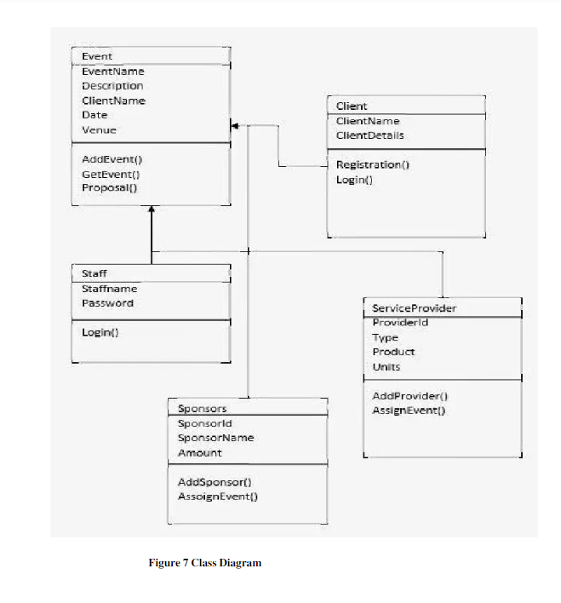

**SSD OF ADD EVENT :**

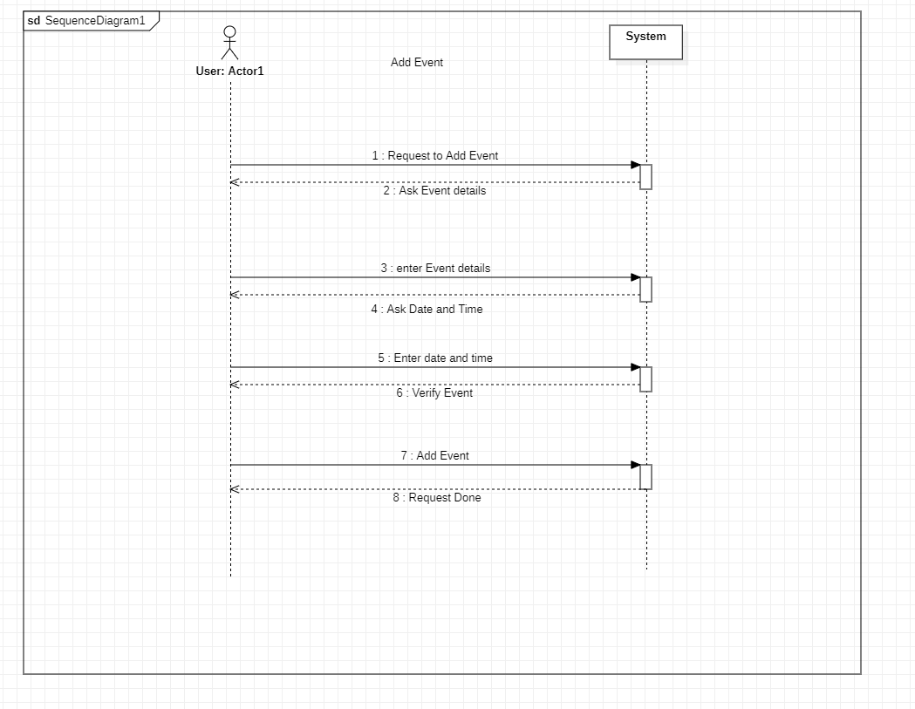

**OPERATIONS CONTRANTS:**

**Contract CO1: Add Event**

Operation Add Event (EventID: EventID, Event Details: Alphabet)

Cross References: Use Cases: Add Event.

Postconditions: Event is successfully added.

**Contract CO2: View Event**

Operation Add Event (EventID: EventID, Event Details: Alphabet)

Cross References: Use Cases: view Event.

Postconditions: Event is view successfully .

**Contract CO3: Delete Event**

Operation Add Event (EventID: EventID, Event Details: Alphabet)

Cross References: Use Cases: Delete Event .

Postconditions: Event is Delete successfully

**---------------------------------------------------------------------**

### Irfan khan FA20-BSE-070

| Use Case UC1: register account |
| --- |
| **Scope**: School management system  **Level**: user goal  **Primary** **Actor**: Student  **Stakeholders and Interests**:  - Student: want to register an account in the School management system.  - Faculty: want to register an account in the School management system.  **Preconditions**: User is identified and authenticated. |

**Success Guarantee** (or Post conditions):

Username is available and account is registered.

Account is not already registered.

**Main Success Scenario (or Basic Flow):**

1. User wants to open the School management system to register an account.
2. System redirects him to the registration page
3. System asks him to provide the details.
4. The user enters username, password, email and address
5. System then checks if the account is already registered or not.
6. If the account is registered the system asks to provide new information or to login
7. If the account is not registered then the system registers the account.
8. System then takes the user to his dashboard where he can access his own profile.

**Extensions (or Alternative Flows):**

*a. At any time when the user tries signing up:

1. user enters the username and password for used when registering his account.
2. The system then verifies his credentials when he clicks on the register button.
3. when the credentials matches then he is redirected to his profile.

*b. At any time when the user tries signing up:

1. user enters the password and username he used when registering his account.
2. The system then verifies his credentials.
3. If the credentials don’t match, then the system displays an error either his password or username is incorrect.

**Special Requirements:**

* + - Text should be visible from 2 meters.
    - Color scheme should be used which is clearly visible.
    - Special characters should be used in username and password.
    - It should take less than 30 second to register an account.
    - Password should be display as ****.
    - Language internationalization on the text displayed.

**Technology and Data Variations List**:

1. Languages used is java.
2. Software used to design interface is netbeans, Gui Swing.
3. Mouse and keyboard are required.

Frequency of Occurrence: Could be nearly continuous.

### Ahsan Ali SP20-BSE-060

Brief Level Use Case

**About Fees:**

This use case will use the student for fee history. A student arrives at a checkout the details of fee. It calculate the all fee challan of the students in institution. Wants to be able to quickly perform override operations, and easily debug students problems.

Fully dressed use case

**Scope:** about fees

**Level:**

**Primary Actors:** Guardians, students, admin

**Stakeholders and Interests**:

Guardian; Guardian wants to know all the fee details without any problem.

Admin: Admin calculate all the fee challan of student in the institution without any error. It can be say that managing the fee problems of students and generate the fee challans. Wants to be able to quickly perform override operations, and easily debug students problems.

Students: Student want to get rid of traditional list to check their details of his fee and this system is very useful for the students for view their updated fee history.

**Main Success Scenario (or Basic Flow):**

1. Guardian wants to know all the fee details without any problem.
2. Admins tells students the total, and asks for payment.
3. System presents receipt
4. Student want to get rid of traditional list to check their details of his fee
5. this system is very useful for the students for view their updated fee history.

**Extensions (or Alternative Flows):**

At any time, System fails:

To support recovery and correct accounting, ensure all transaction sensitive state and events can be recovered from any step of the scenario.

**Special Requirements:**

* **Fee should be submitted through bank.**
* **Fee section visible to guardian.**

**Technology and Data Variations List**:

1. Languages used is java.
2. Software used to design interface is netbeans, Gui Swing.
3. Mouse and keyboard are required.

Frequency of Occurrence: Could be nearly continuous.

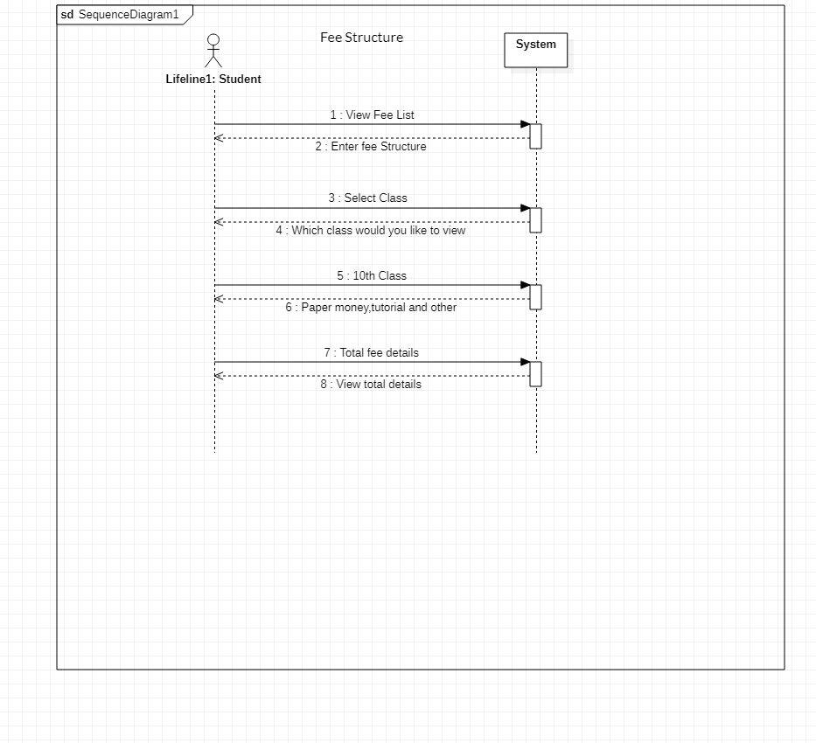

**Screen Shots:**

